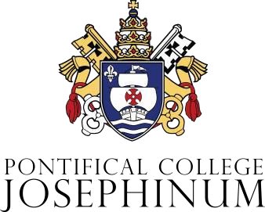

OTHER FINANCIAL AID RESOURCES

Veterans’ Benefits
Often overlooked are many benefits available to veterans and to children of deceased veterans or those disabled in military service. In addition to the benefits offered directly by the Veterans Administration, others are available through their various service organizations, such as the American Legion, Veterans of Foreign Wars, and the Catholic War Veterans, and directly through the branches of the Armed Services. Any possible claim resulting from the current or past military service of the student or a member of the family should be investigated. This program is supervised by the Registrar.

Parental Affiliation Financial Aid Opportunities
You may be surprised at the various potential sources of financial aid. Explore financial aid available through parents' workplaces, military benefits, or religious, ethnic, and fraternal organizations.

Web Site
The following web site allows you to conduct free scholarship searches: www.collegeboard.com/paying

For additional information, please call 614-885-5585 or email the Director of Financial Aid at
the Josephinum at sdean@pcj.edu.

